**The Economist explains**

Why the oil price is falling

Dec 8th 2014, 23:50 BY E.L.

* [Timekeeper](http://www.economist.com/blogs/economist-explains/2014/12/economist-explains-4)

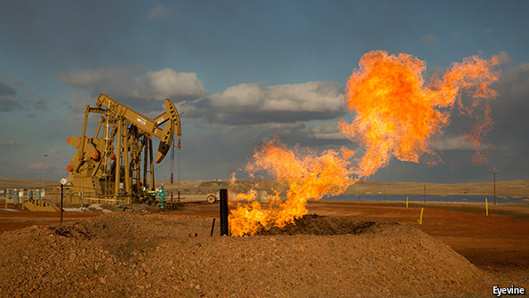

THE oil price has fallen by more than 40% since June, when it was $115 a barrel. It is now below $70. This comes after nearly five years of stability. At a meeting in Vienna on November 27th the Organisation of Petroleum Exporting Countries, which controls nearly 40% of the world market, failed to reach agreement on production curbs, sending the price tumbling. Also hard hit are oil-exporting countries such as Russia (where the rouble has hit record lows), Nigeria, Iran and Venezuela. Why is the price of oil falling?

The oil price is partly determined by actual supply and demand, and partly by expectation. Demand for energy is closely related to economic activity. It also spikes in the winter in the northern hemisphere, and during summers in countries which use air conditioning. Supply can be affected by weather (which prevents tankers loading) and by geopolitical upsets. If producers think the price is staying high, they invest, which after a lag boosts supply. Similarly, low prices lead to an investment drought. OPEC’s decisions shape expectations: if it curbs supply sharply, it can send prices spiking. Saudi Arabia produces nearly 10m barrels a day—a third of the OPEC total.

Four things are now affecting the picture. Demand is low because of weak economic activity, increased efficiency, and a growing switch away from oil to other fuels. Second, turmoil in Iraq and Libya—two big oil producers with nearly 4m barrels a day combined—has not affected their output. The market is more sanguine about geopolitical risk. Thirdly, America has become the world’s largest oil producer. Though it does not export crude oil, it now imports much less, creating a lot of spare supply. Finally, the Saudis and their Gulf allies have decided not to sacrifice their own market share to restore the price. They could curb production sharply, but the main benefits would go to countries they detest such as Iran and Russia. Saudi Arabia can tolerate lower oil prices quite easily. It has $900 billion in reserves. Its own oil costs very little (around $5-6 per barrel) to get out of the ground.

The main effect of this is on the riskiest and most vulnerable bits of the oil industry. These include American frackers who have borrowed heavily on the expectation of continuing high prices. They also include Western oil companies with high-cost projects involving drilling in deep water or in the Arctic, or dealing with maturing and increasingly expensive fields such as the North Sea. But the greatest pain is in countries where the regimes are dependent on a high oil price to pay for costly foreign adventures and expensive social programmes. These include Russia (which is already hit by Western sanctions following its meddling in Ukraine) and Iran (which is paying to keep the Assad regime afloat in Syria). Optimists think economic pain may make these countries more amenable to international pressure. Pessimists fear that when cornered, they may lash out in desperation.  
  
**Dig deeper:**  
[The economics of oil have changed](http://www.economist.com/news/leaders/21635472-economics-oil-have-changed-some-businesses-will-go-bust-market-will-be) (Dec 2014)  
[Will falling oil prices curb America's shale boom?](http://www.economist.com/news/finance-and-economics/21635505-will-falling-oil-prices-curb-americas-shale-boom-bind) (Dec 2014)  
[What is the oil cartel up to?](http://www.economist.com/news/finance-and-economics/21635510-what-oil-cartel-up-making-best-low-price) (Dec 2014)